**JavaFX Registration Form Project**

**1. Project Overview**

This project implements a registration form GUI using JavaFX. The form captures personal details, including name, father's name, CNIC, date of birth, gender, city, and an optional image upload. The application demonstrates a user-friendly interface and basic functionality to display entered data in the console.

**2. Features of the Application**

1. **Graphical User Interface**: Designed using JavaFX, following a clean and responsive layout.
2. **Input Fields**:
   * Name
   * Father's Name
   * CNIC
   * Date of Birth (via DatePicker)
   * Gender (via ComboBox)
   * City (via ComboBox)
3. **Image Upload**:
   * Users can upload an image file.
   * The selected image is displayed within the application.
4. **Buttons**:
   * **Save**: Displays the entered information in the console.
   * **Cancel**: Exits the application.
5. **Welcome Banner**: A title message displayed at the top of the application.

**3. GUI Design**

The application interface is designed using a combination of VBox and GridPane layouts:

* **Welcome Text**: A banner placed at the top using a VBox.
* **Form Elements**: Arranged in rows using GridPane with labels and input fields.
* **Image Upload Section**: Includes an image preview and "Choose Photo" button.
* **Buttons Section**: "Save" and "Cancel" buttons positioned below the form.

**4. How It Works**

**Step-by-Step Workflow**

1. **Launching the Application**:
   * The main form is displayed with labeled input fields and a "Choose Photo" button for image selection.
2. **Entering Data**:
   * Users fill out the form by entering their details into text fields, selecting from dropdowns, or picking a date.
3. **Image Upload**:
   * Users click the "Choose Photo" button to select an image file from their local machine. The selected image is displayed in the application.
4. **Saving the Data**:
   * Clicking the "Save" button retrieves the entered data and displays it in the console, ensuring all fields are validated.
5. **Exiting the Application**:
   * Clicking the "Cancel" button closes the application.
6. **Output Screenshots**

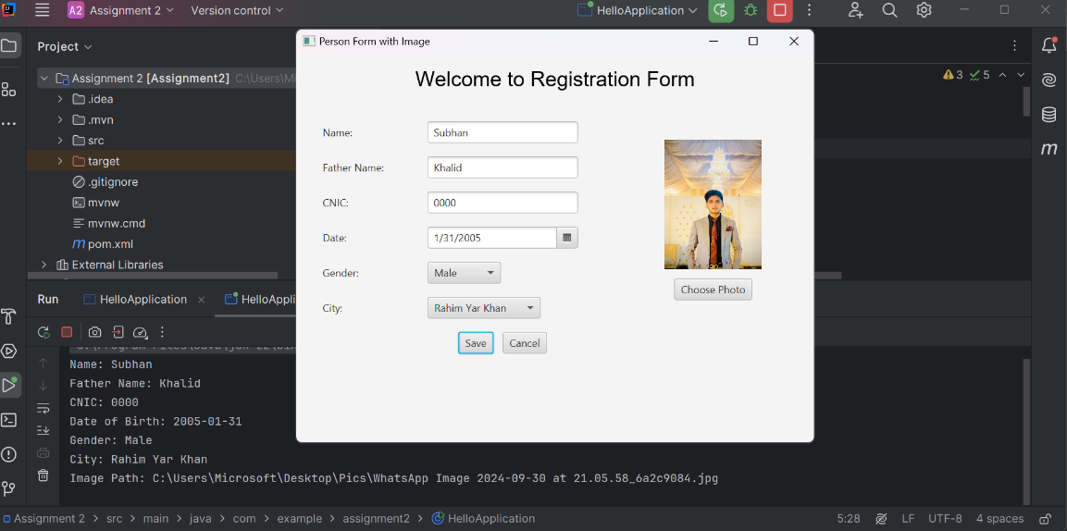

**7.Explanation Main Components:**

1. **Layouts**:
   * VBox: Used for the welcome banner and overall layout.
   * GridPane: Used for organizing form elements into a structured grid.
2. **Controls**:
   * TextField, ComboBox, and DatePicker for input fields.
   * ImageView and Button for image handling.
3. **Event Handling**:
   * **Save Button**: Prints the entered data to the console.
   * **Cancel Button**: Closes the application.
   * **Choose Photo Button**: Opens a file chooser to upload and display an image.